Attention:
Our on line claims viewer is now available for use. Instructions and contact information are below. Contact SIS if you need assistance or more information.

ON LINE CLAIMS VIEWER INSTRUCTIONS FOR “GAP” SUPPLEMENTAL MEDICAL BENEFIT PLANS

Logon to the SIS claims viewing system to see your processed claims.
https://www.sis-ansrware.com/claims.aspx

If you are a new user, go to the “Register Here” section. You will need to enter your last name, date of birth and the last 4 digits of your Social Security number. This is to verify your identity. Dependent spouses and adult children are required to have separate login credentials.

Your user name may not exceed 8 characters and your password will be case-sensitive. If you experience any error messages, please email Special Insurance Services at bbanks@specialinc.com for assistance in completing your registration.

Once you are logged into the system, you will be able to view claims that have been processed within the last 18 months. If you click the “+” sign next to the Patient Name, it will show you additional details. If your claim is pending for a claim form and you would like to download the form and submit it on-line, please follow these steps:

- Click on the “Download Claim Form” button at the bottom of the page.
- Choose the correct claim form. Email customerservice@specialinc.com if you are unsure.
- Complete and sign the form.
- Save it to your computer.
- Click the “Browse” button and select the completed claim form from your computer.
- Click the “Upload Claims Documents” button.

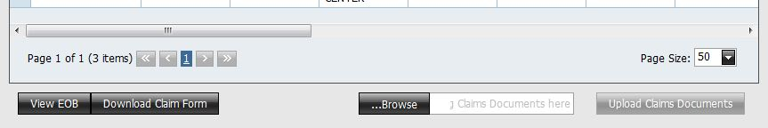

You may also send us any other claim documents by using the “Browse” and “Upload Claims Documents” buttons. This will automatically and securely send your claims documents directly to our claims department.

